  

**2015**

**Molly Barrow #25**

**Molly Barrow #25**

POSITION

PLAYER EMAIL

HONORS

**DOB**

**GPA:**

**Molly Barrow #25**

**DOB:**

**GPA:**

POSITION

PLAYER EMAIL

HONORS

**2015**

**DOB :**

**GPA:**

COMMITTED

**2015**

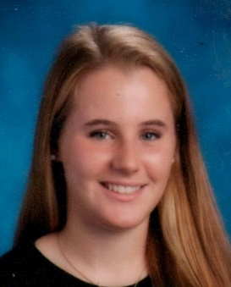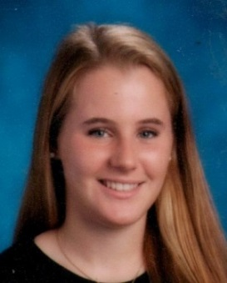 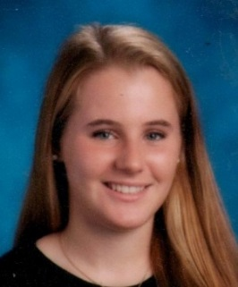 

POSITION

PLAYER EMAIL

HONORS

**DOB**

**GPA:**

**Ariana Bresa #21**

**2015**

POSITION

PLAYER EMAIL

HONORS

**Ariana Bresa #21**

**Ariana Bresa #21**

**DOB:**

**GPA:**

**Ariana Bresa #21**

**2015**

**DOB :**

**GPA:**

POSITION

PLAYER EMAIL

HONORS

**Ariana Bresa #21**

**2015**

**DOB:**

**GPA:**

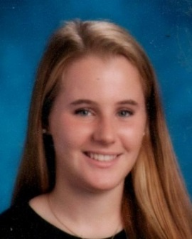  

POSITION

PLAYER EMAIL

HONORS

**DOB:**

**GPA:**

**Ariana Bresa #21**

POSITION

PLAYER EMAIL

HONORS

**DOB:**

**GPA:**

COMMITTED

**2015**

**2015**

  

**DOB:**

**GPA:**

POSITION

PLAYER EMAIL

HONORS

**DOB:**

**GPA:**

**2015**

**Julianna Cabrera #11**

POSITION

PLAYER EMAIL

HONORS

**Julianna Cabrera #11**

**2015**

**DOB:**

**GPA:**

**Julianna Cabrera #11**

**2015**

COMMITTED

**DOB:**

**GPA:**

**DOB: 5-1-97**

**GPA: 4.0**

  

**2015**

**2015**

**DOB:**

**GPA:**

**Kerri Dillon #6**

COMMITTED

**DOB:**

**GPA:**

COMMITTED

**Kerri Dillon #6**

POSITION

PLAYER EMAIL

HONORS

**Kerri Dillon #6**

**2015**